Rensselaer Project Proposal Form  Downtown Revitalization Area (DRI) / NY Forward  Due by 3:00PM on Thursday, September 18, 2025 | Provide information to the best of your ability so we can understand your project. Please reach out if you have any questions.

- Project Sponsor
  - Contact Name:
  - Title:
  - Phone:
  - Email:
  - Business/Organization:
  - Address:
- Project Location
  - Address:
  - Property Ownership:
  - Existing Conditions:

- Project Type:
☐ New Development ☐ Redevelopment and/or Rehabilitation of an Existing Building
☐ Public Improvement ☐ Branding and Marketing
- Project (following the outline below and provide as much information as necessary)
  - Project Title:
  - Project Description:
  - Project Readiness:
  - Project Timeline:
  - Number of Jobs Created: Permanent: Construction/Temporary:
  - Partners:

- Budget Projects should have financing commitments largely secured or be able to demonstrate a clear
path to securing sufficient financing. It is strongly encouraged that all projects, especially private projects, use non-DRI/NY Forward funds that leverage requested public (DRI or NY Forward) funding. The state requires a minimum 25% equity for private projects.

  - Total Cost:
  - DRI Request:
  - Budget Table (see line description below)
Funding Source | Amount | Uses/Action | Status
DRI Request |  |  | Requested

Funding Source: List all Owner Investment, Private Capital, Other Grants, Loans, Etc.
Amount: Amount of funding available, anticipated or requested

Uses/Actions: Are the funds committed to a specific use or action (e.g.: Soft Costs, Abatement, Demolition, Site Work, Construction, Historic Repairs, Specific Renovations, Etc.).

Status: Secured, Committed, Anticipated, Requested, Undetermined, …

- Revitalization Benefit - Describe economic, environmental, social, and/or health beneﬁts that would be gained with this project, such as job creation, additional housing opportunities, preservation of historic structures, redevelopment of vacant or underutilized spaces, remediation of a brownﬁeld, beautiﬁcation, etc.:

- Supplemental Information (Optional) – Attach any of the following that will help explain, describe or support your project.

☐ Images of the existing project site ☐ Images/renderings of the proposed project

☐ Documentation of Project Readiness ☐ Questions

☐ Other Information (please specify):

Certifications
I hereby certify that the information provided in this form is true and correct to the best of my knowledge. In order to be considered for DRI funding, I agree to provide timely responses to requests for additional information from New York State and/or its DRI consultants.

Project Sponsor Signature:
Date:

I understand that submission of this form does not constitute an application for or guarantee of funding from New York State, that the information provided herein will be reviewed and considered by the DRI Local Planning Committee for possible inclusion in the DRI Strategic Investment Plan. I further understand that inclusion in the DRI Strategic Investment Plan does not constitute a guarantee of funding from New York State, that all funding decisions will be made by New York State, and if funded I will comply with all State funding requirements.

Project Sponsor Signature:
Date:

Further, I hereby acknowledge that I have read the DRI project criteria and understand that any DRI funding provided for projects will made available on a reimbursement basis only after expenses are incurred or in some cases, after a project has been successfully completed in its entirety. I also understand that DRI funding will be subject to all applicable New York State requirements, including, but not limited to MWBE utilization, competitive procurement for goods and services, and project status reporting.

Project Sponsor Signature:
Date:
All Applications are due by 3:00PM on Thursday, September 18, 2025 to be considered
for inclusion in the City of Rensselaer DRI / NY Forward Application to New York State.

To submit via email:  Email your completed application and any supplemental materials to Thomas Hulihan at thomas.hulihan@rensselaerny.gov | To mail or hand deviver a hard copy:  Planning Department  DRI Preliminary Proposal  Rensselaer City Hall  62 Washington Street  Rensselaer, NY 1214

Rensselaer DRI Boundary

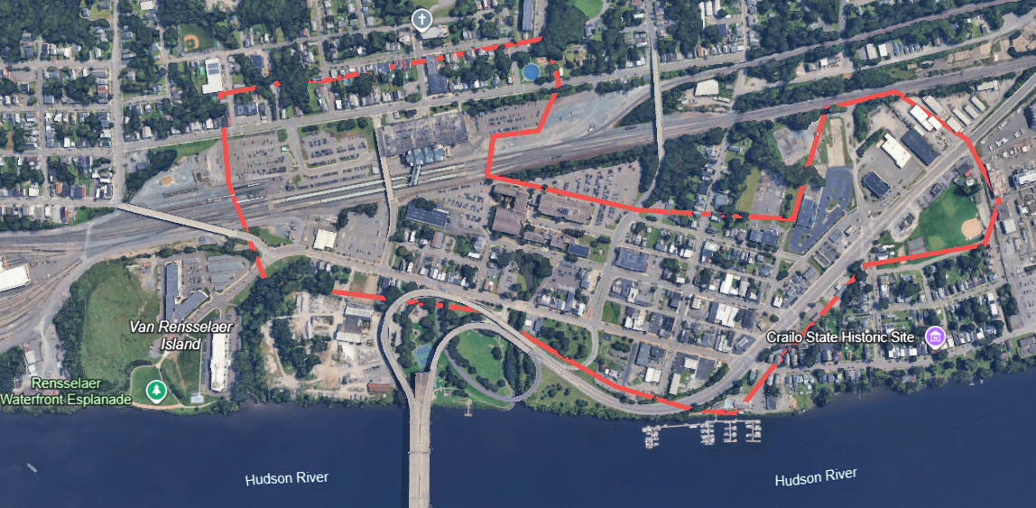

The City of Rensselaer Round 8 Downtown Revitalization (DRI) Boundary is shown above. We are seeking transformative projects for an improved and expanded downtown. The expanded downtown area, shown above, includes parts of Columbia Street, Broadway, Herrick, East Street and areas in between. Adjacent and nearby transformative projects that will have a significant impact on this area will also be considered.



Discussion Session (Optional): September 3, 2025 from 3:00 – 5:00PM

Come to Rensselaer City Hall anytime between these hours to discuss your project with city staff and consultants from LaBella Associates.
All Applications are due by 3:00PM on Thursday, September 18, 2025 to be considered
for inclusion in the City of Rensselaer DRI / NY Forward Application to New York State.

